**AWS Advanced Projects (Day9)**

**========================================**

**PROJECT 1: Working with Elastic Load Balancer**

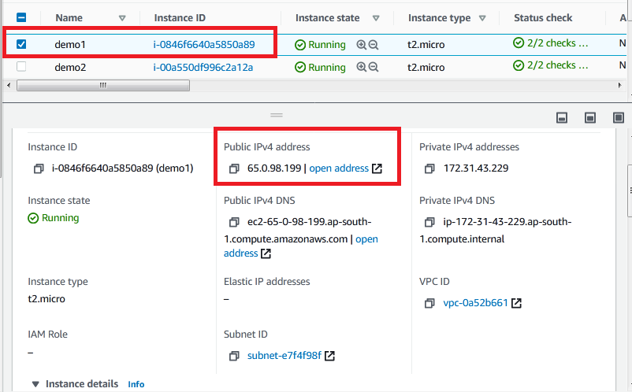

Fig. 1.1 Instance 1

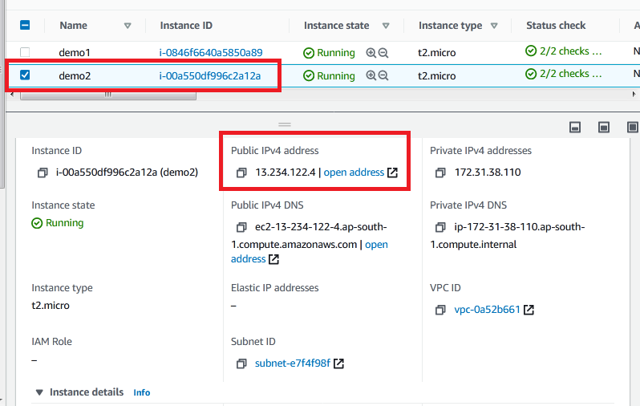

Fig. 1.2 Instance 2

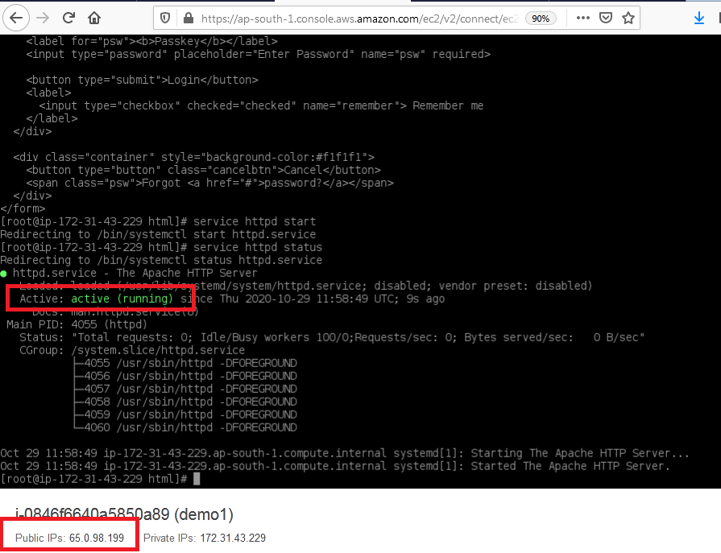

Fig. 1.3 Instance 1 running status

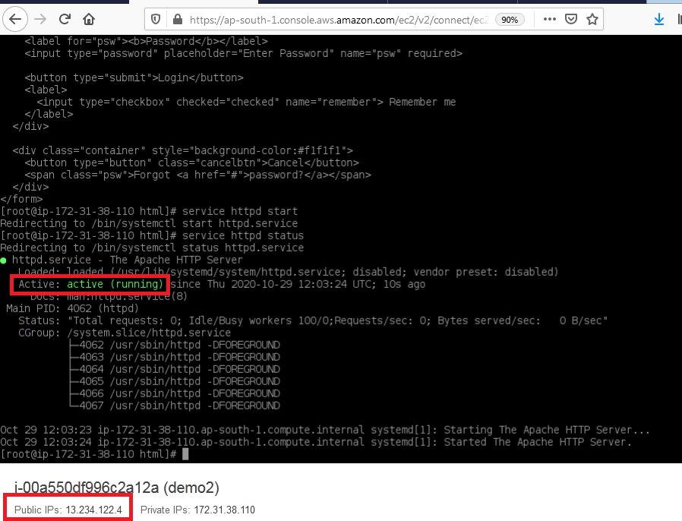

Fig. 1.4 Instance 2 running status

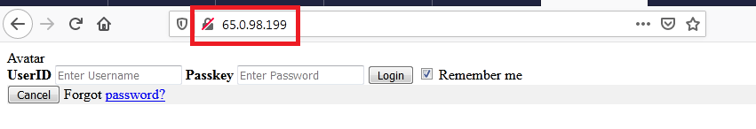

Fig. 1.5 Instance 1 login page

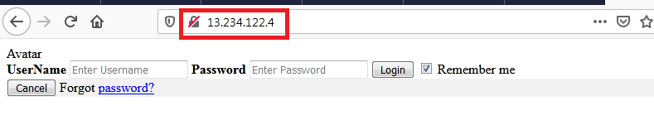

Fig. 1.6 Instance 2 login page

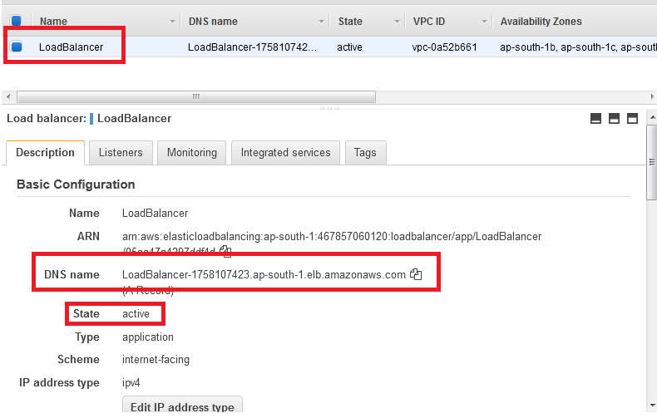

Fig. 1.7 Load Balancer

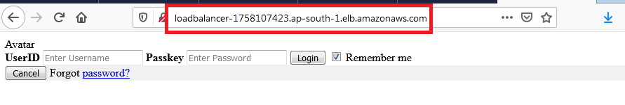

Fig. 1.8 Load Balancer response from server1 using DNS

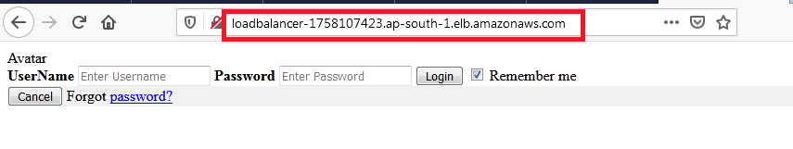

Fig. 1.9 Load Balancer response from server2 using DNS

**PROJECT 2: Creating a User Pool in AWS Cognito**

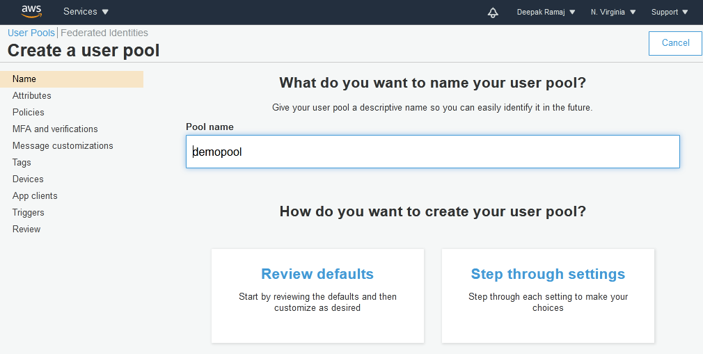

Fig. 2.1 Name

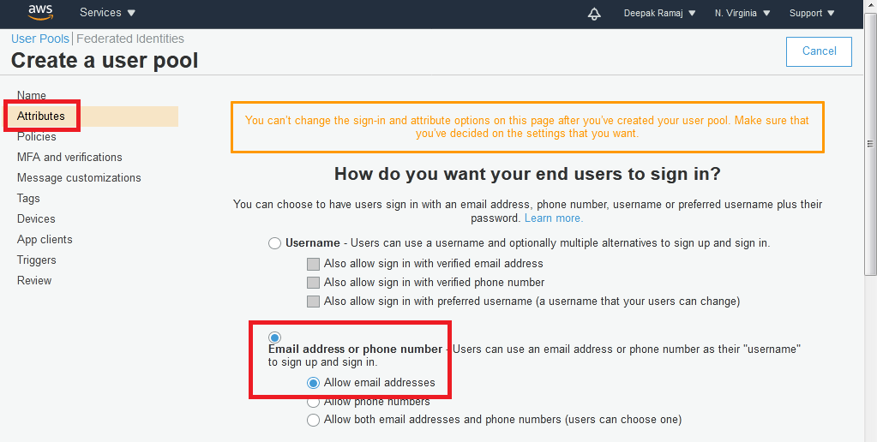

Fig. 2.2 Attribute

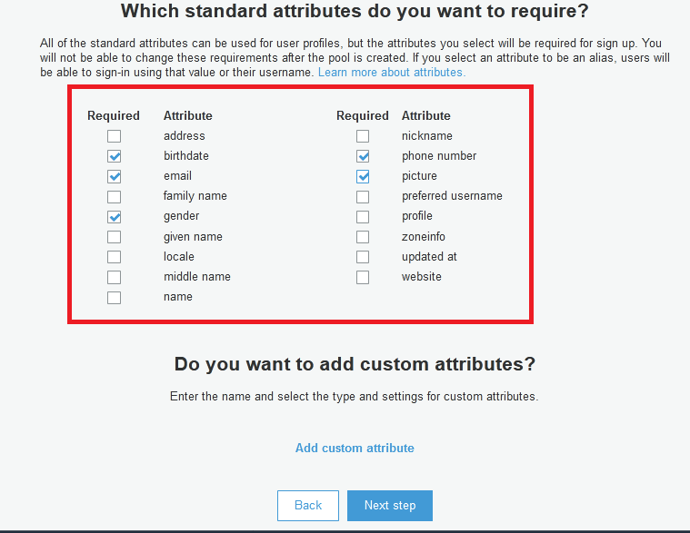

Fig. 2.2.1 Attribute

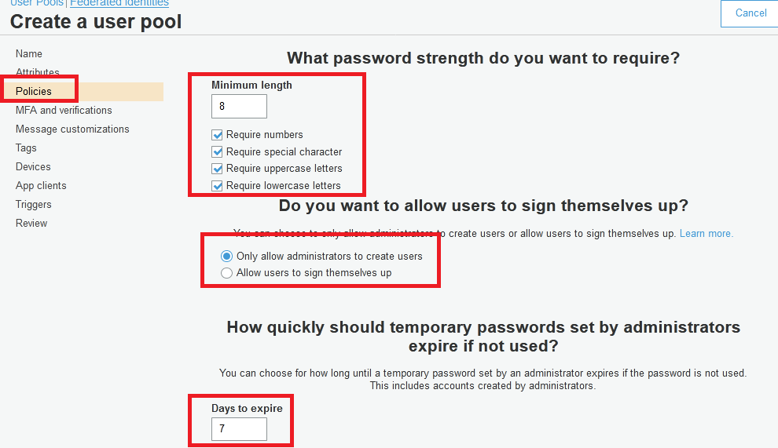

Fig. 2.3 Policies

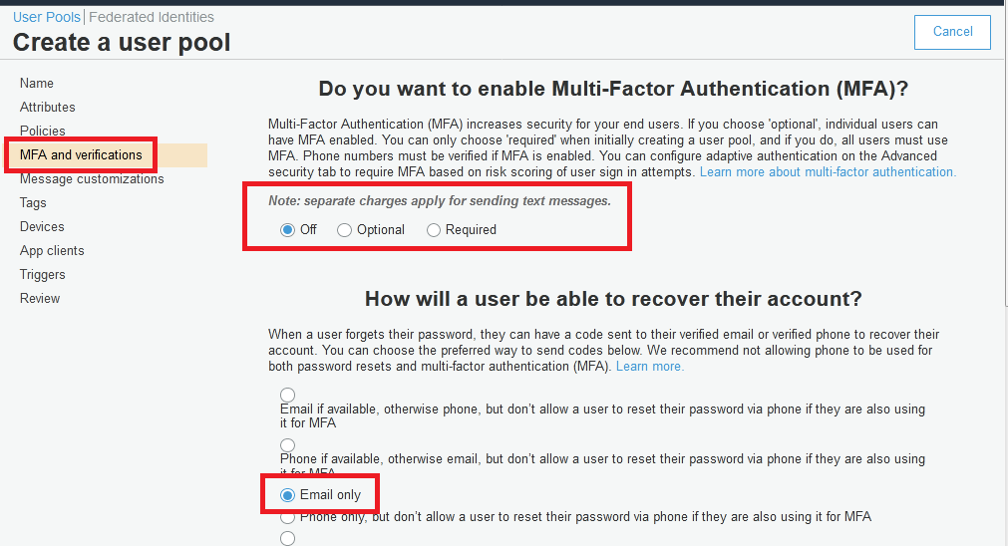

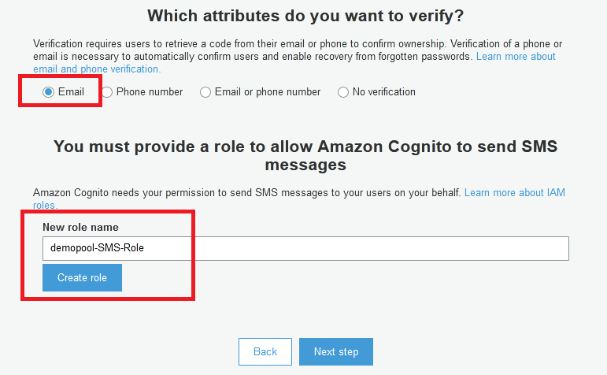

Fig. 2.4 MFA and verification

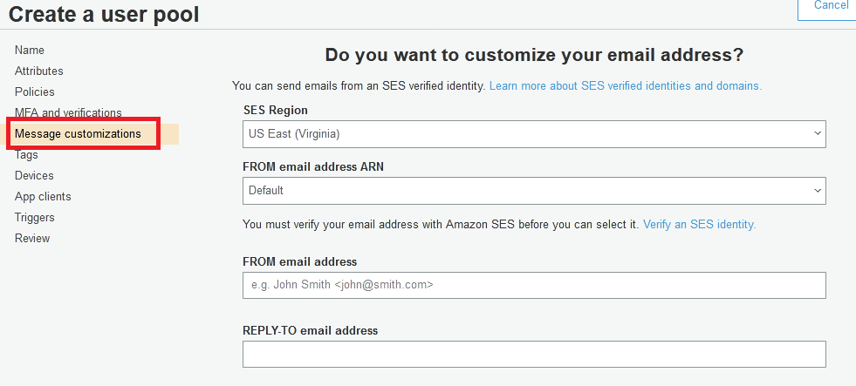

Fig. 2.5 Message customization

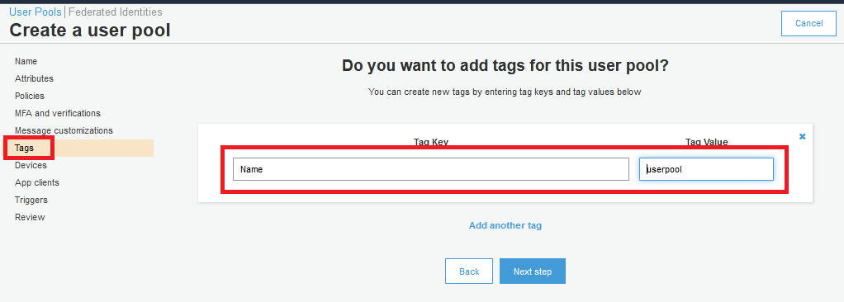

Fig. 2.6 Tags

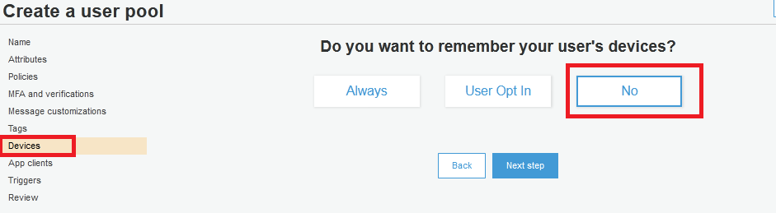

Fig. 2.7 Devices

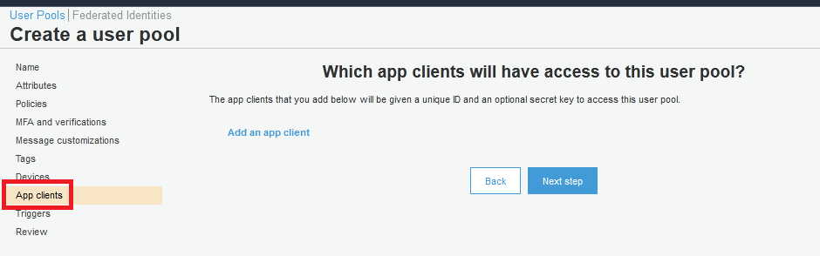

Fig. 2.8 App clients

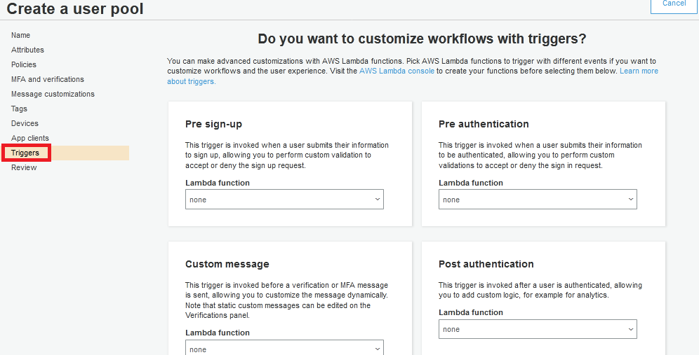

Fig. 2.9 Triggers

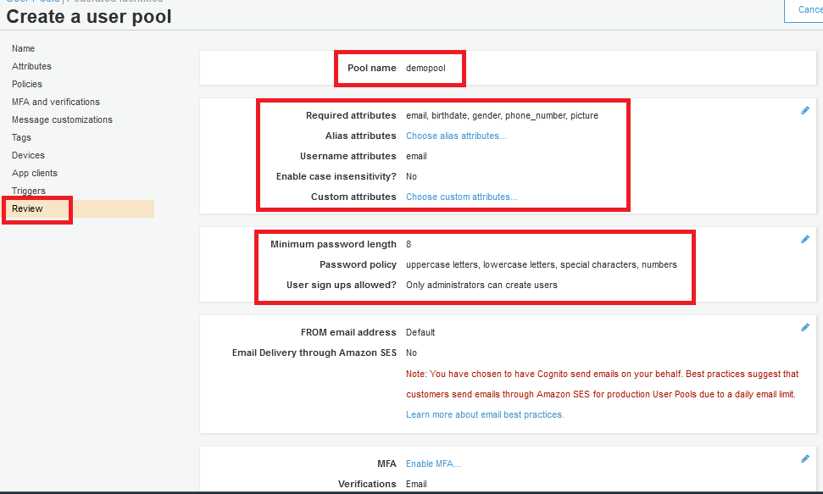

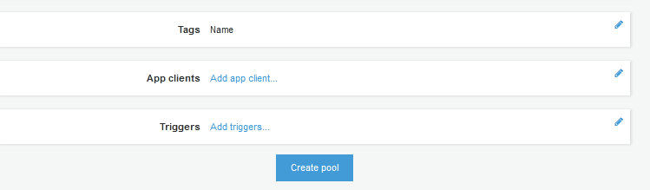

Fig. 2.10 Review

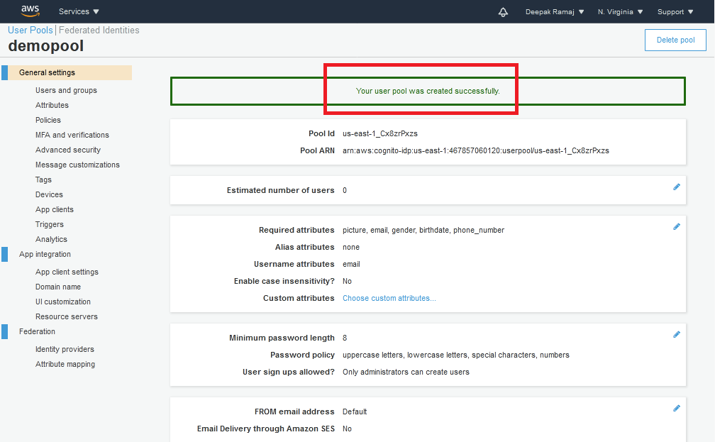

Fig. 2.11 User pool created

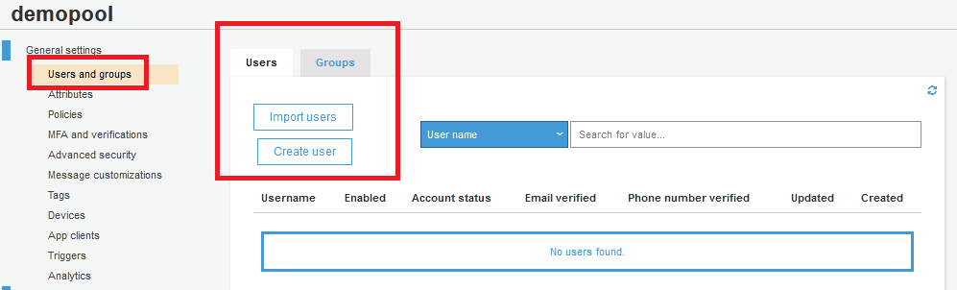

Fig. 2.11.1 Users and Groups

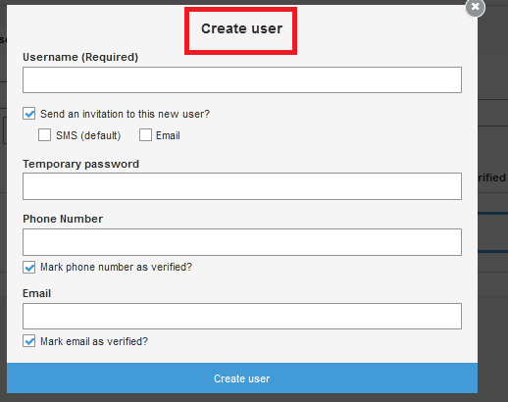

Fig. 2.11.2 Create User

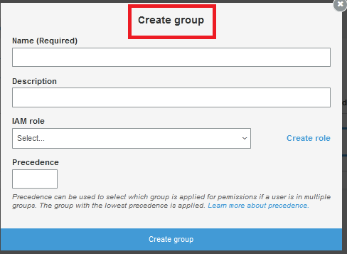

Fig. 2.11.3 Create Group